**EXP NO 1 - FLIGHT RESERVATION SYSTEM**

**Aim:** To create an application form for the flight reservation system by using zoho application.

**PROCEDURE:**

**STEP1:** GOTO ZOHO.COM

**STEP 2:** LOGIN TO THE ZOHO.COM

**STEP 3:** SELECT ONE APPLICATION

**STEP 4:** ENTER APPLICATION NAME

**STEP 5:** CREATED NEW APPLICATION

**STEP 6:** SELECT ONE FORM

**STEP 7:** THE SOFTWARE HASE BEEN CREATED.

**Procedure:**

**Step 1: GOTO ZOHO.COM**



**STEP 2: LOGINTOTHE ZOHO.COM**

**STEP 3: SELECT ONE APPLICATION**

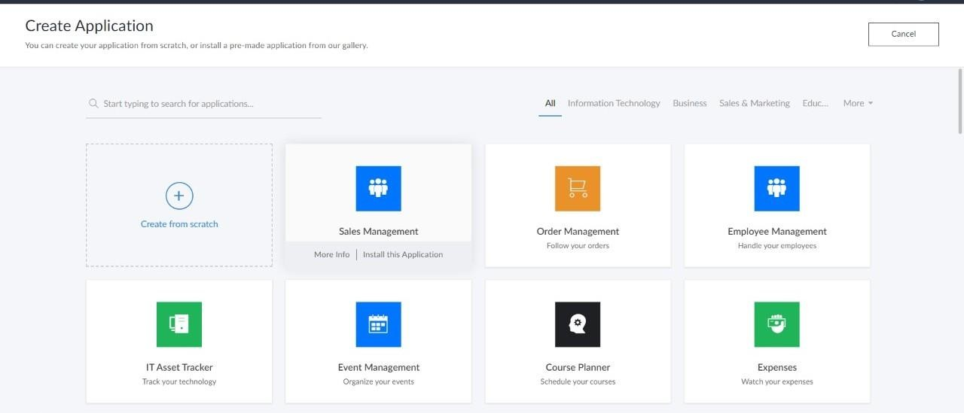

**STEP 4: ENTER APPLICATION NAME**

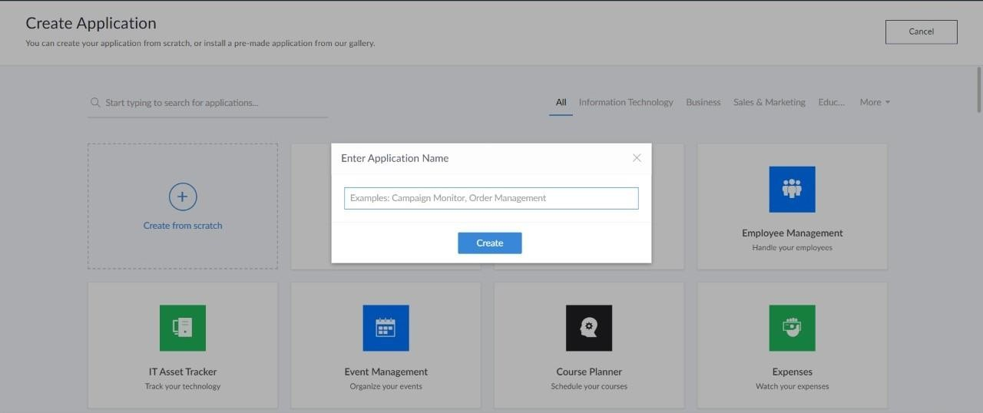

**STEP 6: SELECT ONE FORM**

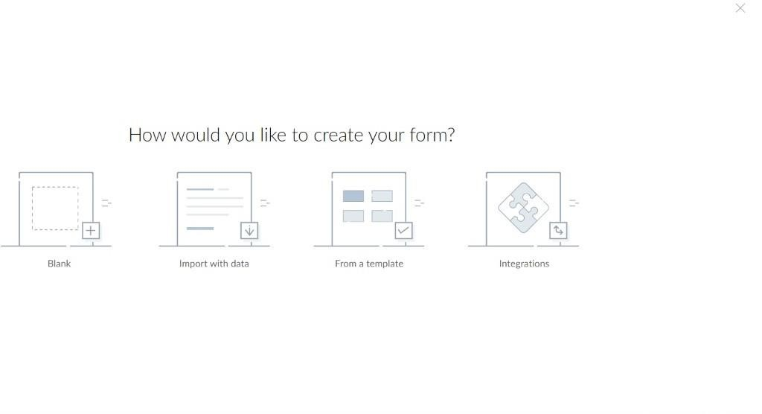

**STEP 7: THE SOFTWARE HASE BEEN CREATED.**

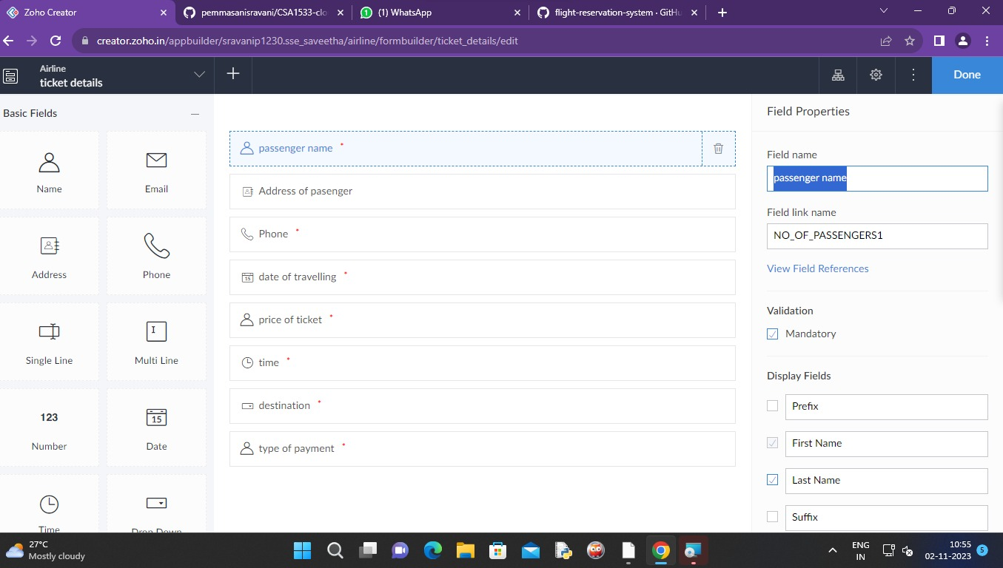

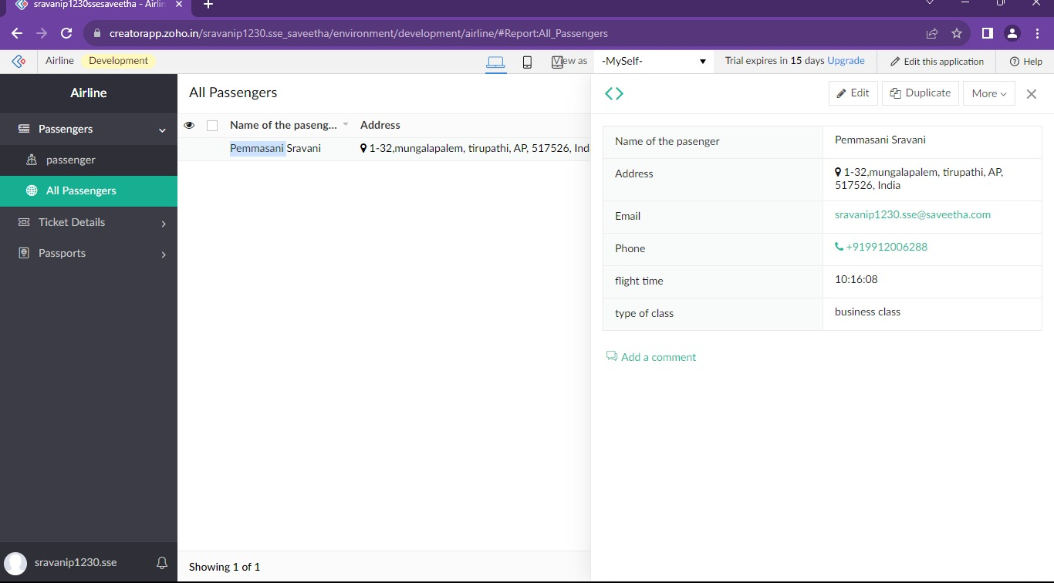

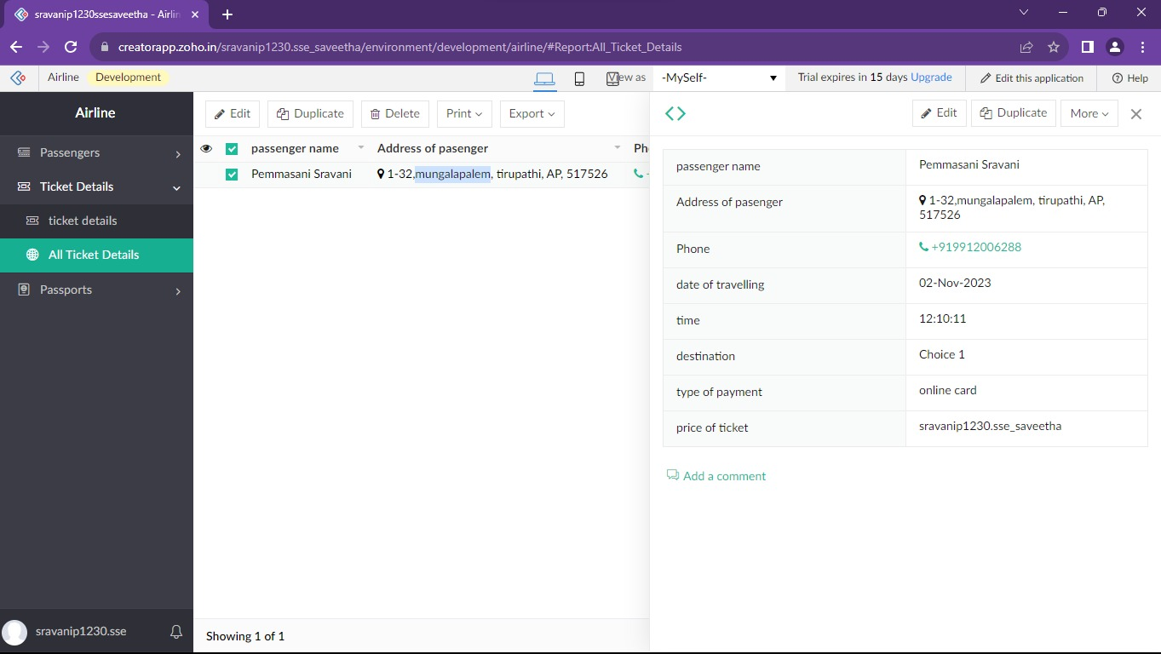



**Result:**

Successfully created a form for tickets reservation system by using ZOHO application.